**MY SQL QUERIES**

**COFFEE SHOP SALES PROJECT**

* Creating Database

create database coffee_shop_sales_db;

* Using the Database :

use coffee_shop_sales_db;

* DATA TYPES OF DIFFERENT COLUMNS :

describe coffee_shop_sales;

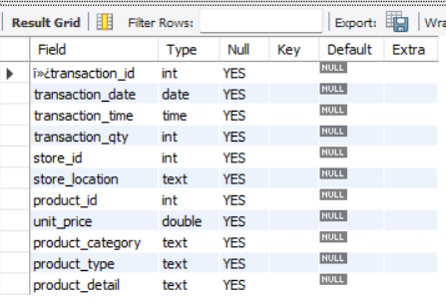

* CONVERT TIME (transaction_time) COLUMN TO PROPER DATE FORMAT :

UPDATE coffee_shop_sales

SET transaction_time = STR_TO_DATE(transaction_time, '%H:%i:%s');

* ALTERING TIME (transaction_time) COLUMN TO DATE DATA TYPE :

alter table coffee_shop_sales

modify column transaction_time time;

* CONVERTING DATE (transaction_date) COLUMN TO PROPER DATE FORMAT :

UPDATE coffee_shop_sales

SET transaction_date = STR_TO_DATE(transaction_date, '%d:%m:%Y');

* ALTERING DATE (transaction_date) COLUMN TO DATE DATA TYPE

alter table coffee_shop_sales

modify column transaction_date date;

* TOTAL SALES FOR MAY MONTH

select round(sum(unit_price*transaction_qty),1) as Total_Sales

from coffee_shop_sales

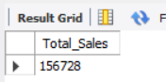

* TOTAL SALES KPI - MOM DIFFERENCE AND MOM GROWTH

select month(transaction_date) as month, -- number of month

round(sum(unit_price * transaction_qty)) as Total_Sales, -- total sales

(sum(unit_price * transaction_qty) - lag(sum(unit_price * transaction_qty),1) -- Month difference Sales

over(order by month(transaction_date))) / lag(sum(unit_price*transaction_qty),1) -- division by previous month sales

over(order by month(transaction_date))* 100 as mom_increase_percentage -- percentage mom=Month on Month

from coffee_shop_sales

where month(transaction_date) in (4,5) -- for month of April(Previous Month) and May(Current Month)

group by month(transaction_date)

order by month(transaction_date);

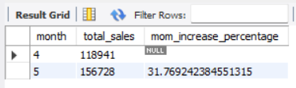

* TOTAL ORDERS

select count(transaction_id) as Total_Sales from coffee_shop_sales

where month(transaction_date)=5; -- for March month

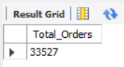

* TOTAL ORDERS KPI - MOM DIFFERENCE AND MOM GROWTH

select month(transaction_date) as month, -- number of month

round(count(transaction_id)) as Total_Order, -- total sales

(count(transaction_id) - lag(count(transaction_id),1) -- Month difference Sales

over(order by month(transaction_date))) / lag(count(transaction_id),1) -- division by previous month sales

over(order by month(transaction_date))* 100 as mom_increase_percentage -- percentage mom=Month on Month

from coffee_shop_sales

where month(transaction_date) in (4,5) -- for month of April(Previous Month) and May(Current Month)

group by month(transaction_date)

order by month(transaction_date);

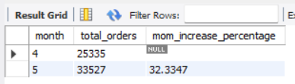

* TOTAL QUANTITY SOLD

select sum(transaction_qty) as Total_Quantity from coffee_shop_sales

where month(transaction_date)=5; -- MAY month

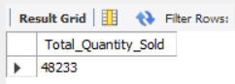

* TOTAL QUANTITY SOLD KPI - MOM DIFFERENCE AND MOM GROWTH

select month(transaction_date) as month,

round(sum(transaction_qty)) as total_qty_sold,

(sum(transaction_qty) - lag(sum(transaction_qty),1)

over(order by month(transaction_date))) / lag(sum(transaction_qty),1)

over(order by month(transaction_date)) * 100 as mom_increased_percentage

from coffee_shop_sales

where month(transaction_date) in (4,5)

group by month(transaction_date)

order by month(transaction_date);

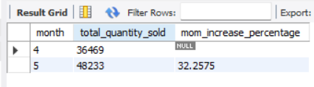

* CALENDAR TABLE – DAILY SALES, QUANTITY and TOTAL ORDERS WITH Rounded off values

select concat(round(sum(unit_price * transaction_qty)/1000,1),'K') as Total_Sales,

concat(round(sum(transaction_qty)/1000,1),'K') as Total_Quantity_Sold,

concat(round(count(transaction_id)/1000,1),'K') as Total_Orders

from coffee_shop_sales

where transaction_date = '2023-05-18';

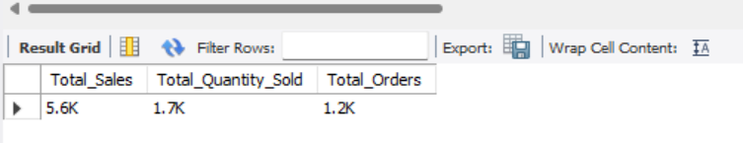

* SALES BY WEEKDAY / WEEKEND:

select

case when dayofweek(transaction_date) in (1,7) then 'Weekends'

else 'Weekdays'

end as 'Day_type' ,

concat(round(sum(unit_price * transaction_qty)/1000,1),'K') as Total_Sales

from coffee_shop_sales

where month(transaction_date)=5 -- MAY Month

group by

case when dayofweek(transaction_date) in (1,7) then 'Weekends'

else 'Weekdays'

end;

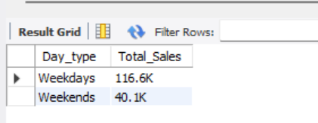

* SALES BY STORE LOCATION

select store_location,concat(round(sum(unit_price * transaction_qty)/1000,1),'K') as Total_Sales

from coffee_shop_sales

where month(transaction_date) = 5 -- May Month

group by store_location

order by sum(unit_price * transaction_qty) desc;

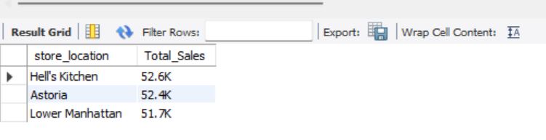

* SALES TREND OVER PERIOD

select concat(round(avg(total_sales)/1000,1),'K') as Avg_Sales

from(

select sum(unit_price * transaction_qty) as total_sales

from coffee_shop_sales

where month(transaction_date) = 5 -- May Month

group by transaction_date

) as Internal_query;

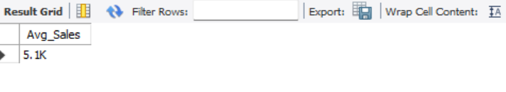

* DAILY SALES FOR MONTH SELECTED

select day(transaction_date) as Day_of_Month,

sum(unit_price * transaction_qty) as Total_Sales

from coffee_shop_sales

where month(transaction_date) =5 – MAY Month

group by day(transaction_date)

order by day(transaction_date);

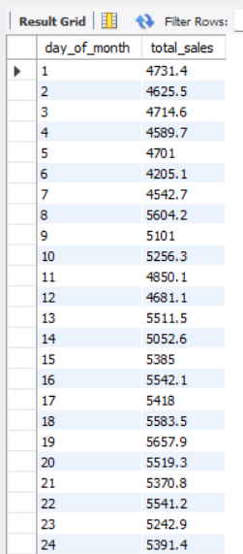 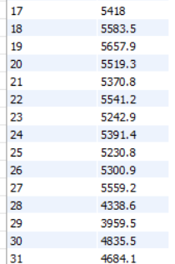

* COMPARING DAILY SALES WITH AVERAGE SALES – IF GREATER THAN “ABOVE AVERAGE” and LESSER THAN “BELOW AVERAGE”

select day_of_month,

case

when total_sales > avg_sales then 'Above Average'

when total_sales < avg_sales then 'Below Average'

else 'Average'

end as sales_status,

total_sales from (

select day(transaction_date) as day_of_month,

SUM(unit_price * transaction_qty) AS total_sales,

avg(sum(unit_price * transaction_qty)) over() as avg_sales

from coffee_shop_sales

where month(transaction_date) = 5 -- May Month

group by day(transaction_date)

order by day(transaction_date)

) as sales_data

order by day_of_month;

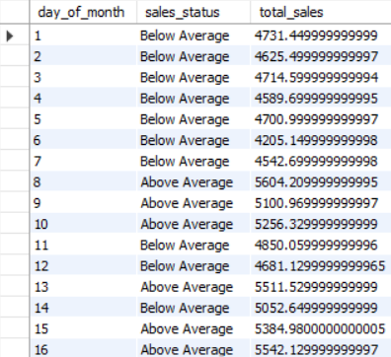

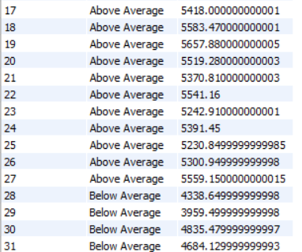

* SALES BY PRODUCT CATEGORY

select product_category, sum(unit_price * transaction_qty) as total_sales

from coffee_shop_sales

where month(transaction_date)=5

group by product_category

order by total_sales desc;

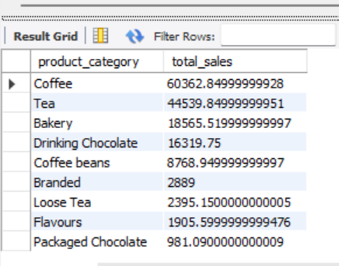

* SALES BY PRODUCTS (TOP 10)

select product_type, sum(unit_price * transaction_qty) as total_sales

from coffee_shop_sales

where month(transaction_date)=5 and product_category='Coffee'

group by product_type

order by total_sales desc

limit 10;

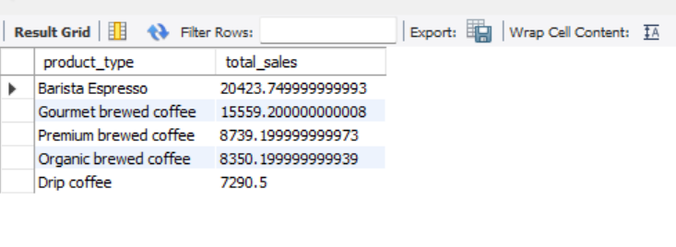

* SALES BY DAY | HOUR

select sum(unit_price * transaction_qty) as total_sales,

sum(transaction_qty) as Total_qty_Sold,

count(*) as Total_Orders

from coffee_shop_sales

where month(transaction_date) = 5 -- May month

and dayofweek(transaction_date) = 3 -- Monday

and hour(transaction_time) = 8; -- hour no 8

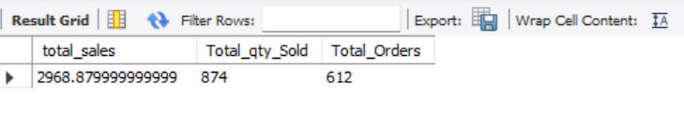

* TO GET SALES FOR ALL HOURS FOR MONTH OF MAY

select hour(transaction_time) as hours_of_day,

sum(unit_price * transaction_qty) as total_sales

from coffee_shop_sales

where month(transaction_date) = 5

group by hour(transaction_time)

order by hour(transaction_time);

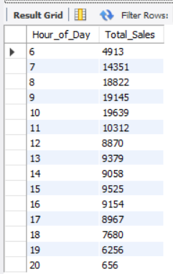

* TO GET SALES FROM MONDAY TO SUNDAY FOR MONTH OF MAY

SELECT

CASE

WHEN DAYOFWEEK(transaction_date) = 2 THEN 'Monday'

WHEN DAYOFWEEK(transaction_date) = 3 THEN 'Tuesday'

WHEN DAYOFWEEK(transaction_date) = 4 THEN 'Wednesday'

WHEN DAYOFWEEK(transaction_date) = 5 THEN 'Thursday'

WHEN DAYOFWEEK(transaction_date) = 6 THEN 'Friday'

WHEN DAYOFWEEK(transaction_date) = 7 THEN 'Saturday'

ELSE 'Sunday'

END AS Day_of_Week,

ROUND(SUM(unit_price * transaction_qty)) AS Total_Sales

FROM

coffee_shop_sales

WHERE

MONTH(transaction_date) = 5 -- Filter for May (month number 5)

GROUP BY

CASE

WHEN DAYOFWEEK(transaction_date) = 2 THEN 'Monday'

WHEN DAYOFWEEK(transaction_date) = 3 THEN 'Tuesday'

WHEN DAYOFWEEK(transaction_date) = 4 THEN 'Wednesday'

WHEN DAYOFWEEK(transaction_date) = 5 THEN 'Thursday'

WHEN DAYOFWEEK(transaction_date) = 6 THEN 'Friday'

WHEN DAYOFWEEK(transaction_date) = 7 THEN 'Saturday'

ELSE 'Sunday'

END;

